

The Lighthouse
Zion & Trinity Lutheran Churches
950 Huron
St. Ignace, MI 49781

Address Service Requested

Nonprofit Org.
U.S. Postage
PAID
St. Ignace, MI 49781
Permit No. 55

,

THE LIGHTHOUSE

Newsletter for December 2014

The night is nearly over; the day is almost here. So let us put aside the deeds of darkness and put on the armor of light.
Romans 13:12

Message from Our Pastor
From Pastor Lamb... Some questions about our church:
Why do we have the Church? Well, the short answer is that God loves us, and created the Church for us because we need it. God created it when, as Jesus promised, the Holy Spirit was sent to invade people and stir them into action. (In the Church this event is called Pentecost, or the birthday of the Church. It happened in Jerusalem some 50 days after Jesus' resurrection. So we have the Church because God started it, thought we needed it, and wanted us to have it.
What does the Church do? In the Bible, we learn that God wants the Church (the Spirit-stirred people) to do this:
- love the Lord our God with all our heart and soul and mind and strength (includes worship);
- love our neighbor as ourselves and as Jesus loves us (includes caring for others by giving yourself and your resources in service to them);
- make disciples (apprentices) of Jesus Christ (includes education, or faith formation); and
- tell people about the life and work and power of Jesus Christ, who taught, was killed, resurrected, and now lives; and who relates to us as savior, teacher, master and friend (includes preaching, conversations with others, community events that invite people in, etc.).
So how does the Holy Spirit stir us to be the Church? I don't know how the Holy Spirit does it. But I do know what Spirit-stirred-up people look like. A lot of them regularly gather to honor God and offer God their worship. Some of them show up at house fires and accidents as volunteer EMT's, paramedics, or firemen. Some of them are coaches, or quilt-makers, or cookie-makers, or prisoner visitors, or newsletter writers, or church council members, or youth group leaders, . A lot of them get together to encourage one another, and to be encouraged by one another over coffee and snacks. The Holy Spirit stirs a lot of people to open their checkbooks and write checks to help people they don't know and will never meet. I have heard Spirit-stirred people speak words of forgiveness and hope at a cost to themselves. I have seen Spirit-stirred-up people come with their hands out seeking help, seeking connection with God; and I have seen the joy, the hope, the comfort in their eyes when they receive the body and blood of Jesus. I have seen them ponder holy mysteries when listening to the Bible being read and hearing that nothing – nothing – can separate them from God.
Why do we still have the Church? The Holy Spirit, the powerful partner with us in this work and event we call the Church, is still stirring people up to do the things God wants done, and to be the people God wants us to be.
God wants the Church to be here for us, so it is. It is there to equip us to share our lives in the community around us. It is here to strengthen our connection to God. It is here for us to share our abundant joy, love, encouragement, peace, forgiveness, and life. It is here to help us when we are in need of joy, love, encouragement, peace, forgiveness, and life. It is here to inspire you and me, to build our faith, to speak God's good news of acceptance and forgiveness to us. It is here to help us honor, worship, and follow God. It is here for us.
NOW THIS IS A VERY IMPORTANT POINT: There may be times you don't feel stirred by the Spirit to be part of the community we know as the Church. That is OK! I'll say it again: that is OK! Don't feel guilty about that. The spirit blows where it will, and we don't know when it will blow into a particular person's heart and mind. But know this for sure: when it does blow into your heart and stirs you to come to worship, or to build your faith, or to share what God has given you, or to seek what God has to offer – know that the Church will be here for you. It will always be here for you.
And through your presence and participation it will be there for others, too.
Amen.
Matt Lamb, Interim Pastor

Newsletter

The Newsletter was not adopted.

Noisy Offering

The noisy offering for December 7th will go for the Mackinac County Children’s Toy Drive.

NOIZ & Confirmation Caroling

Sunday, December 14th at 2 pm, all High School Youth and Confirmation Youth will be going caroling followed by snacks at the church. Join us in spreading Christmas cheer!

Confirmation

Confirmation will meet on the first two Wednesday at 7 pm.

Bake Sale/Can Drive

The NOIZ group will be hosting a Bake Sale/Food Can Drive at Family Fare to raise money for the Food Pantry on Saturday, December 13th at 9 am.

Food Pantry

During the month of December
Zion will be collecting food
cans for the Food Pantry.
During the winter months,
the need always increases.

Choir

There is only one choir practice this month on December 3rd at 7 pm.

Annual Christmas Musicale

Come enjoy the choir at the Annual Christmas Musicale at the United Methodist Church on December 7th at 6:30 pm.

Christmas Dinner

Join us on Friday, December 6th at 5:00 pm for Trinity’s Second Annual Christmas Dinner.

Christmas Services

Join us as we celebrate the birth of our Savior on Christmas Eve. Trinity will meet at 5 p.m. and Zion at 8:00 p.m.

Youth Gathering in Detroit

The ELCA Youth Gathering for high school-age youth (8th thru 12th) takes place every three years and is about faith formation, worship, study, fellowship, service and play. The next Gathering will be held July 15-19, 2015, in Detroit, Mich.
We will be raising money for the Youth Gathering by collecting pop cans and recycling toner and inkjet & laser print cartridges. Any contributions will be appreciated. Anyone wanting to go, please contact Sandy Feleppa (643-6793), Nicole Garen (643-8387) or Lana Lennington (643-6576).

Prayer List

( If you would like someone added to the prayer list, please fill out a yellow card or call the church)

Bonnie Bergeron, Jim Dyer, Carl & Mary Belonga, LaTaunya Paquin, Lois Movalson, Phil Richel, Joy Olsen Marolf, Jim Scott, Bob Pearson, Susan Stelzer, Rob Podlesak, Judy Childs, Jackie Kallstrom, Judy Schlehuber Bridges, Terry Jacobson, Sandy White, Beverly Kammers, Terry Howard, Doris McFarland, Ray Burton, Janet Kanitz, Frank Feher, Phil Schaeffer, Charlie Lamoreaux, Hallie Marshall, George Ford, Kay Allot, Wayne Chapple, Kathy Essary, Philip Huff, Ruth Visnaw, Brenda St. Onge, Krista Empie, Pastor Matt Lamb, James Dandona, Judy Ryerse, Barb Lehto, Ben Doran, Alicia Garen and the family of Warren Christiansen, the family of Christine Movalson Shaw, and the families of Basil and Paula Wolfe.


Advent

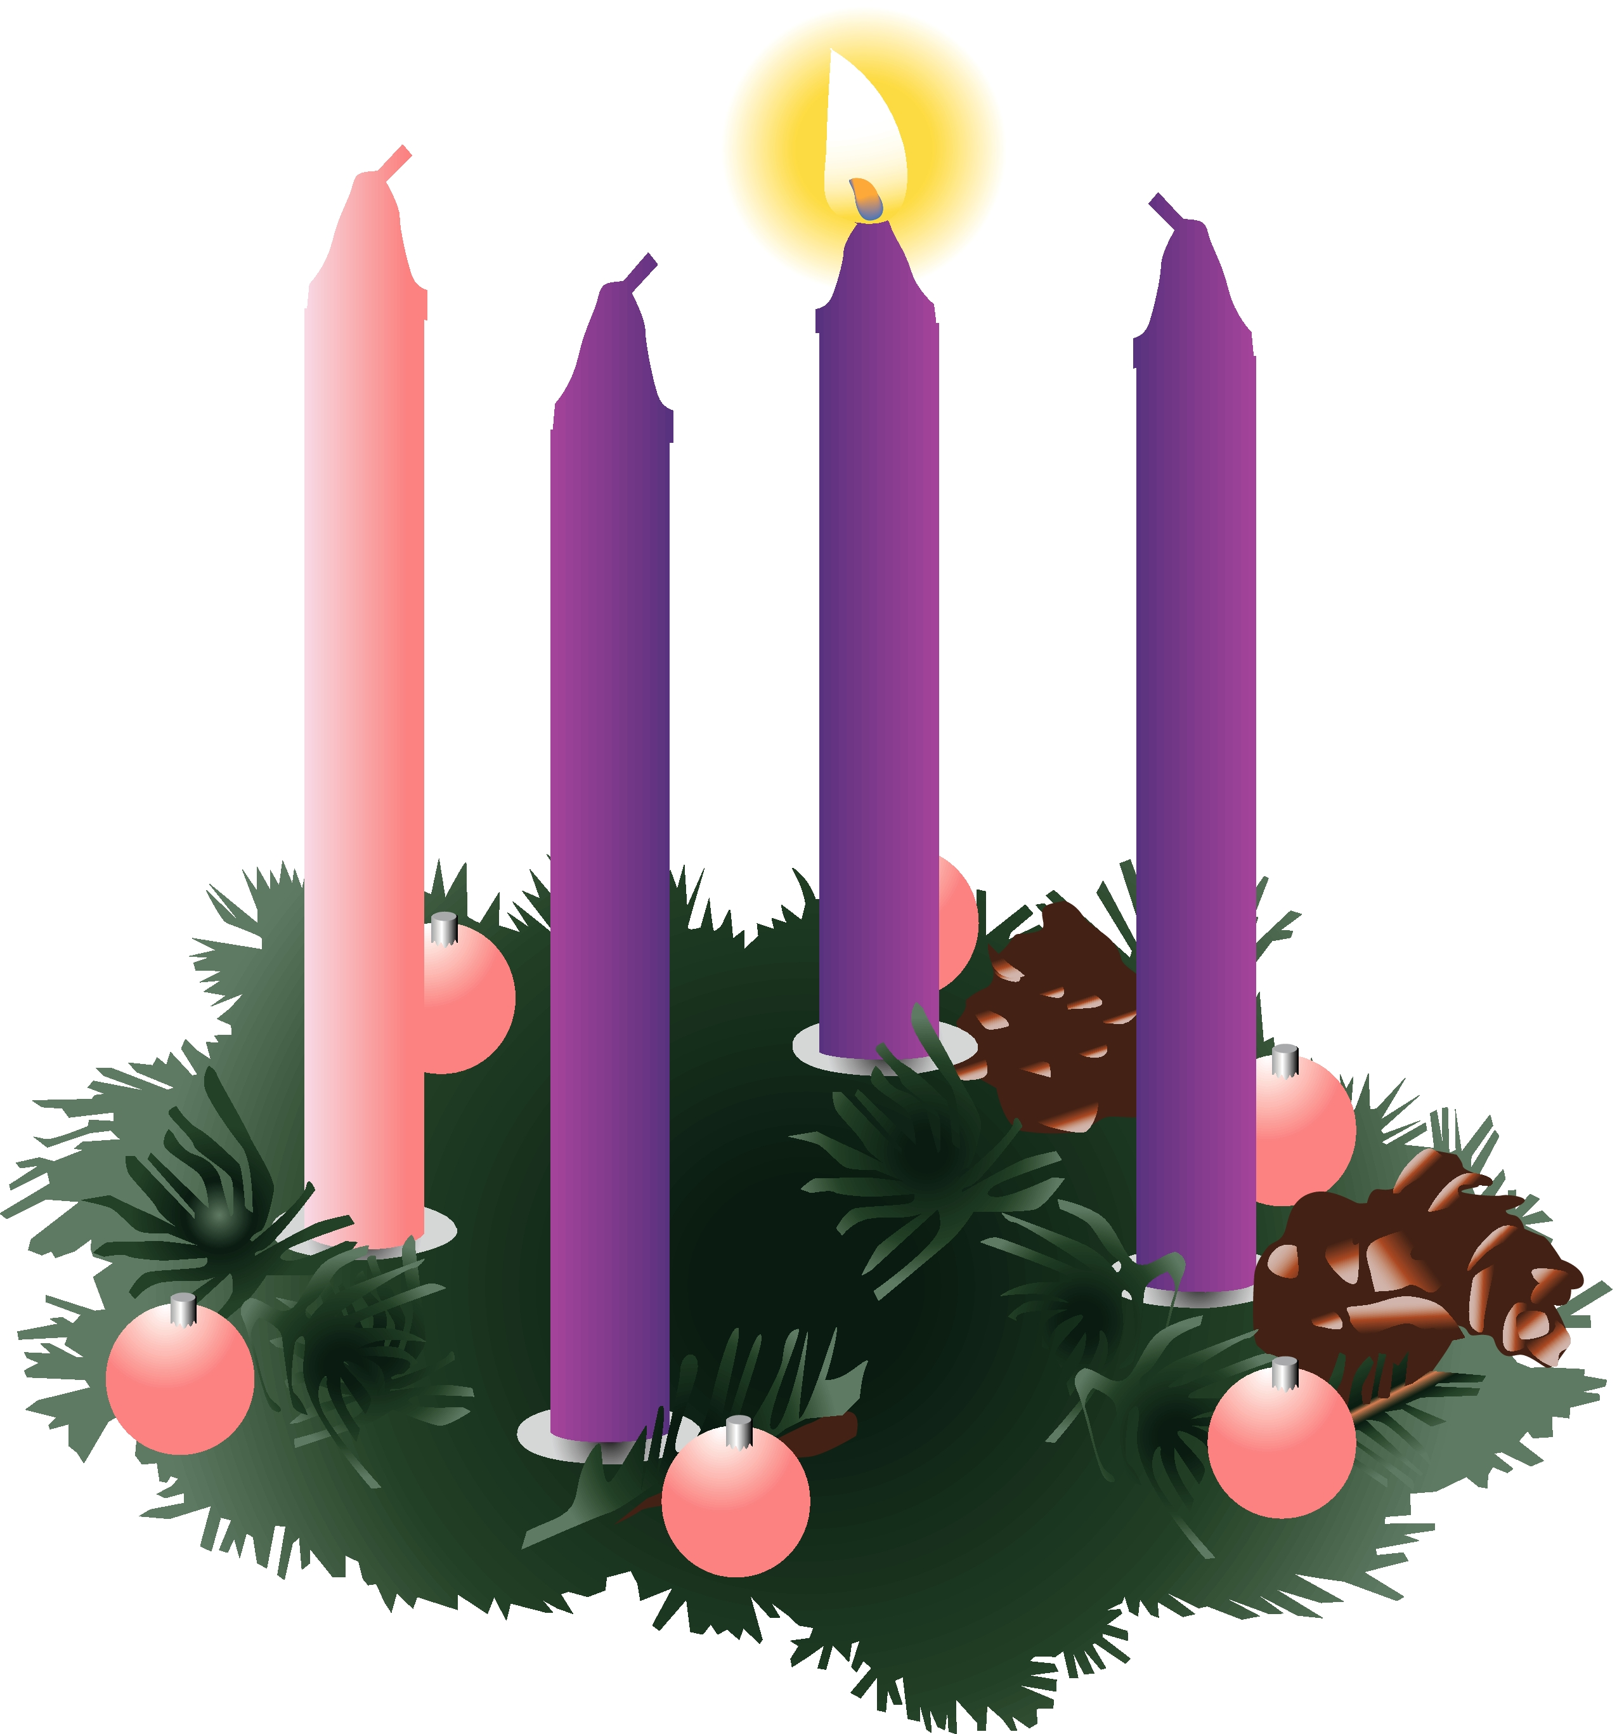
Advent begins November 30! Advent is a time to focus inward and prepare our hearts and lives for Christ. This is the countdown and earnest waiting for the Messiah. Please take some time during this season to:

- Worship weekly
- Pray daily
- Read your Bible daily
- Practice generosity

Anniversaries in December

December 1 Dave & Lois Movalson
December 10 Jim & Jerri Rose
December 28 Tim & Sally Idalski

Birthdays in December

December 2 Andrea Insley
4 Bonnie Bergeron
- Joyce Gustafson
- Josh LaJoice
- Sue St. Onge
12 Trudy Olsen
14 Bill Harju
15 Tonya Winberg
17 Phil Schaeffer
20 Robby Olsen
22 Sally Idalski
23 Chase DeKeyser
24 Carol Elmblad
24 Toby Ferguson
25 Robert Marshall
26 Lorraine Graham
29 Barb Wilkins
30 Mike Lehto

Baptismal Anniversaries

December 2 Madison Olsen
3 Kelly LaJoice
7 Zoey Stenson
9 Brad Therrian
15 Rita LaVake
15 Connie Olsen
19 Joshua Feleppa
20 Lana Lennington
20 Sue St. Onge
24 Bernard Crouch
24 Katti Gamble
24 Alicia Garen
24 Cole Garen

25 Jordan Caldwell
27 Dawn Akers
27 Lucas Hammond
27 Brent Ruff
27 Jayce Ruff
27 Drew Stockero
28 Kristine Vallier
29 Barb Wilkins
30 Max Coburn

Contact Information

Interim Pastor: Pastor Matt Lamb may be reached at 906-647-2818 or 717-805-4210 (cell phone number - please call anytime you need to!)

Church telephone: 906-643-7870 - Answering machine
The secretary will usually be in the office on Tuesday and Thursday mornings.

To email the church is: ziontrinity950@yahoo.com
The new website is at http://zionstignace.com/home.html
- Find us on facebook at www.facebook.com/zionstignace

Leftover dishes

There are various dishes left over from donations to the soup
luncheons, funerals, etc. They have been taken upstairs. We appreciate your help. Check to see if you’ve forgotten one.
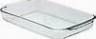

Evergreen Living Center Craft Show

Resident Craft Show to raise money for the Activities Department.
December 15th, 4 – 6 pm
December 16th, 9 am to 6 pm

Zion Funeral Committee December-March

Team Leader: Linda Wilkins (643-7710)
Co-leader: Marlene Olsen (643-9519)

Trinity Worship Families

Dec 7 Baron Family
Dec 14 Kennedy Family
Dec 21 Chalmers Family
Dec 24 Rose Family
Dec 28 Movalson Family

Servants for Zion

Ushers & Greeters
Dec 7 Sjogren Family
Dec 14 Jerry & Susan Fenlon
Dec 21 Dena Barker & Tracey McCluskey
Dec 24 Lana Lennington Family
Dec 28 Judy Ryerse & Donna Harju

Lectors
Dec 7 Sandy Feleppa
Dec 14 Lorraine Graham
Dec 21 Fred Feleppa
Dec 24 Betsy Turf
Dec 28 Rita LaVake

Communion Assistants
Dec 7 Nicole Garen
Dec 14 Lorraine Graham
Dec 21 Fred Feleppa
Dec 24 Paul Shepard

Acolytes
Dec 7 Emma Feleppa
Dec 14 Casey Brake
Dec 21 Kennedy Kammers
Dec 24 Donovan Insley
Dec 28 Ryan LaVake

Pulpit Supply
Dec 7 Katherine Finegan , Asst. to the Bishop
Dec 14 Kerry Shimkovitz
Dec 21 Mike Herman
Dec 24 Dan Litzner
Dec 28 Dan Litzner

Altar: Mike Herman
Money Counters: Carol Elmblad & Martha Sjogren
Council Meetings

Trinity Council Meeting – 6 pm, December 3rd
Zion Council Meeting – 6:30 pm, December 11th

Zion’s Council Members

President: Faith Gaubault 298-1800
Vice-President Paul Shepard 984-2069
Secretary: Lorraine Graham 643-8419
Co-Treasurers: Dawn Akers 643-7552
Lana Lennington 643-6576
Nicole Garen 298-0490
Tim Idalski 643-6574
Fred Feleppa 643-6793

Trinity’s Council Members

President: Jerri Rose 292-5570
Vice-President Tracy Movalson 292-5581
Secretary: Sharon Chalmers 292-5440
Treasurer: Pega Kennedy 292-5633
Co-Treasurer: Jim Rose 292-5570
Financial Secretary: Joe Chalmers 292-5433
WELCA: Pega Kennedy 292-5633
John Kennedy 292-5633
Jim Dyer 292-5433
Lois Movalson 292-5581
Treasurer's Report for Zion
January 1, 2014 to November 15, 2014
Income:
 | Building | $ 5,472.00
 | Church Use Income | $ 150.00
 | Thrivent Financial Income | $ 339.00
 | General | $ 49,364.33
 | Trinity Share | $ 11,785.00
 | TOTAL |  | $ 70,784.27
Expenses:
 | Administration | $ 4,907.52
 | Benevolence | $ 3,770.00
 | Church Maintenance | $ 13,276.37
 | Education | $ 882.12
 | Parsonage Maintenance | $ 2,134.44
 | Pastoral | $ 34,329.24
 | Worship | $ 5,387.61
 | --To Building Fund | $ 5,403.00
 | --To LCF Loan | $ 500.00
 |  |  | $ 70,590.30
 |  |  | 193.97
***********************************************************
General fund balance: |  |  | $ 694.38
Building fund balance:  (Still owe Marshall Builders $332.00) |  |  | $ 322.59
WELCA Kitchen Savings acct balance: |  |  | $ 686.43
General fund owes building fund: |  |  | $ 235.00
General fund owes Mission Endowment fund: |  |  | $ 9,495.00

Zion Lutheran Council Meeting
November 19, 2014
Present: Pastor Lamb, Fred Feleppa, Lorraine Graham and Lana Lennington

Pastor Lamb and Lana went through the mail that came throughout the month.

Lorraine Graham opened the meeting at 7:00 p.m. Pastor Lamb led us in devotions and a prayer.

Pastor’s Report:

Pastor Lamb stated since the last meeting, he has been off because of his surgery. Today he did visitations and came to our meeting. He stated Barb Lehto should be getting out of the hospital tomorrow.

The Treasurer’s Report was presented.

It was decided that enough people were not present to make any decisions but that we could still discuss what was coming up.

Old Business:

Lana stated we should start collecting food cans for the annual food drive before the holidays.

Lana stated she is still trying to find teachers to teach Sunday School for two Sundays a month.

Lana stated that so far 3 Confirmation students and 1 NOIZ student were interested in going to the Youth Gathering.

Lorraine stated that as we had no lay volunteers for the long-term care service on Sunday, we would be having a Sing-along Service.

Lorraine stated that since Advent was starting on the 30th we needed to change the decorating day to Saturday, November 29th at 10 am.

New Business:

Fred stated he would try to get together and Endowment Fund Meeting within the next month.

Pastor Lamb stated that also during the next month we would need to get a budget together for the annual meeting. We need to get a Call Committee together with someone to chair it. To start our calling process he wanted to begin with a Bible Study session with the council and to work on a church profile. Lana volunteered for the Call Committee as she had work on the one for Pastor Jeremy. Fred said he would try to email the council to come up with a date for the Bible Study meeting.

Lana stated she would get together with Nicole to decide if and when the Confirmation and NOIZ groups would go caroling.

Lorraine stated that we would need to update the usher list for next year and would bring it to the next meeting. Lana made a suggestion that Lorraine work on it and then the council could fill in the blanks.

Respectfully submitted,
Lorraine Graham

Three Lakes Lay Academy
Winter Schedule

Three Lakes Lay Academy has just finished another round of classes with a graduation for 5 students on November 20, 2014. We will begin another round of classes with the January- March schedule. This will give people the opportunity to start at the beginning and provide for them a three-year sequence of classes leading to a certificate of accomplishment. If you or anyone wishes to see a copy of the list of classes for the next three years please let me know and I will send it on.
Registration is now open for January 2015 and you are welcome to register and participate this coming term.
Dave Van Dam and Bre Johnson

Three Lakes Lay Academy
Winter 2015 Class Offerings

Schedule:
Thursdays from January 15 – March 19, 2015
4:00 pm – Church Story
5:30 pm – Shared meal
6:00 pm – Shared Devotions
6:30 pm – Introduction to the Bible
8:00 pm – Depart

Classes:

Church Story An overview of the Church’s story leading up to the Reformation with a concentration of study on the Reformation that birthed the Lutheran and Presbyterian Churches.
Teachers:
Rev. Jesse Brown – Lutheran Pastor, Newberry, MI
Presbyterian still to be determined
An Introduction to the Bible - An overview of one of the greatest books in the world that seeks to explore the historical and literary contexts as well as the common threads that run through the fabric of Scripture
Teachers:
Rev. David Van Dam – Retired Presbyterian Pastor, Petoskey, MI
Rev. Bre Johnson – Lutheran Pastor, Cedarville, MI

All classes held at:
Zion Evangelical Lutheran Church
950 Huron St, St. Ignace, MI 49781
906-643-7870

Each class is $10 for the semester. Students will be required to purchase books. Scholarships are available. Classes are team taught by Presbyterian and Lutheran teachers.

Please pre-register at davidvandam68@gmail.com or UPBRE3@gmail.com before January 12, 2012 to make sure you can get books by the first class!

For further information please contact: Rev. David Van Dam at 231-439-5069, davidvandam68@gmail.com

In its tenth year, The Academy is a cooperative teaching ministry of the congregations of the Evangelical Lutheran Church in America (ELCA) and the Presbyterian Church (USA) in the eastern Upper Peninsula, and the northern Lower Peninsula of Michigan. The Academy was founded to meet the need of Christian adults to study more in depth on issues of God and faith.

Santa Arrives in St. Ignace December 5th

Holiday Music by G-Man Entertainment
4:30 p.m. – throughout downtown

Celebrate the Holidays Wine & Beer Tasting
5:00 p.m. – 7:00 p.m. at The Pavillion
$5.00 for six tastings – Hors d’oeuvres & Music by Charlie Reager

Santa Arrives at Arnold Line Dock #1
6:00 p.m.

Lighting of the Christmas Tree
Arnold Line Dock #1

Santa Land – Following the Tree Lighting at KC Hobbies
Treats sponsored by the St. Ignace Business Association

Pictures with Santa
Following the tree lighting at KC Hobbies.
Professional photos with Santa by Resort Photography.

Lindsey Vork Photography
Christmas Mini-Sessions at the Colonial House Inn

Allied EMS Tours & Treats
First National Bank Parking Lot during Santa’s visit at Santa Land.

Merry Christmas!



Wishing You a Blessed Christmas!

